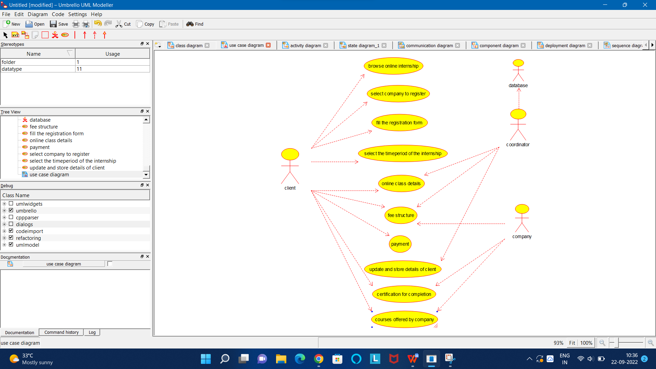

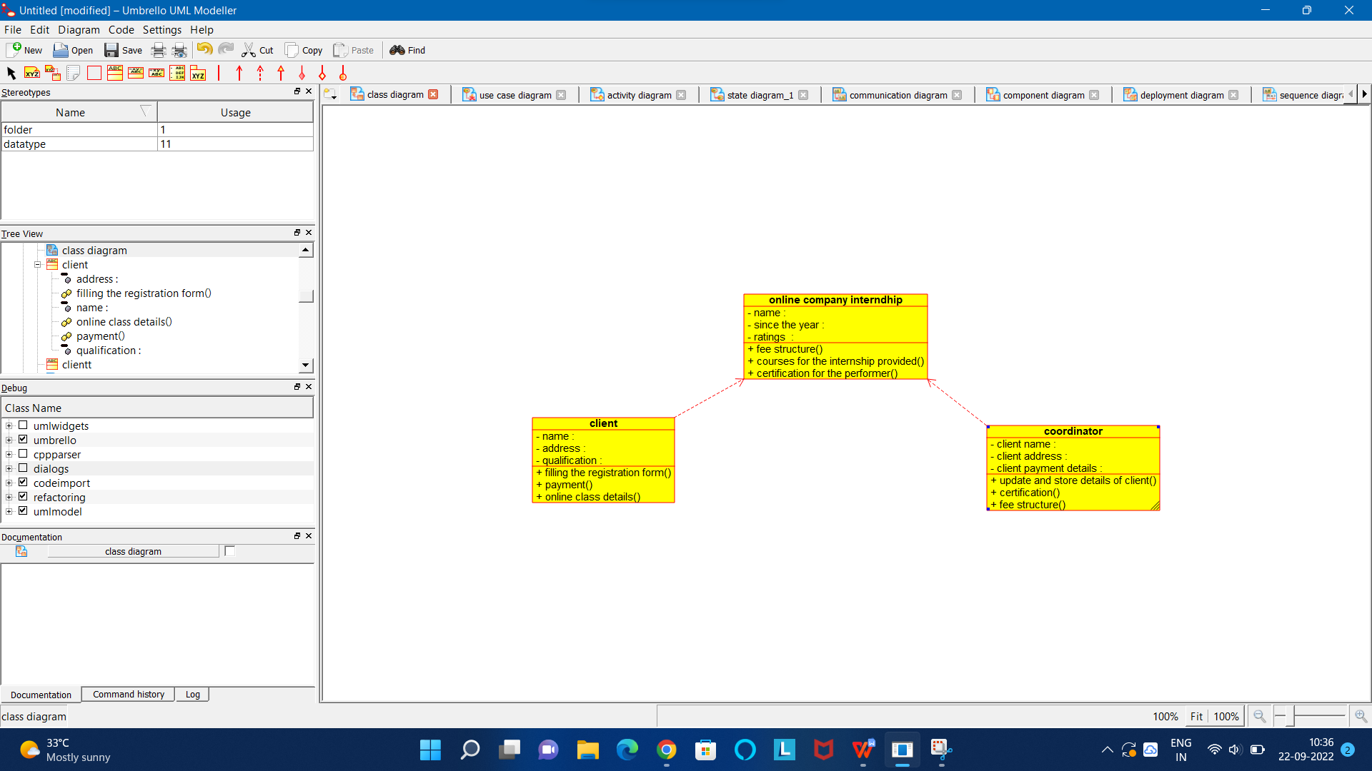

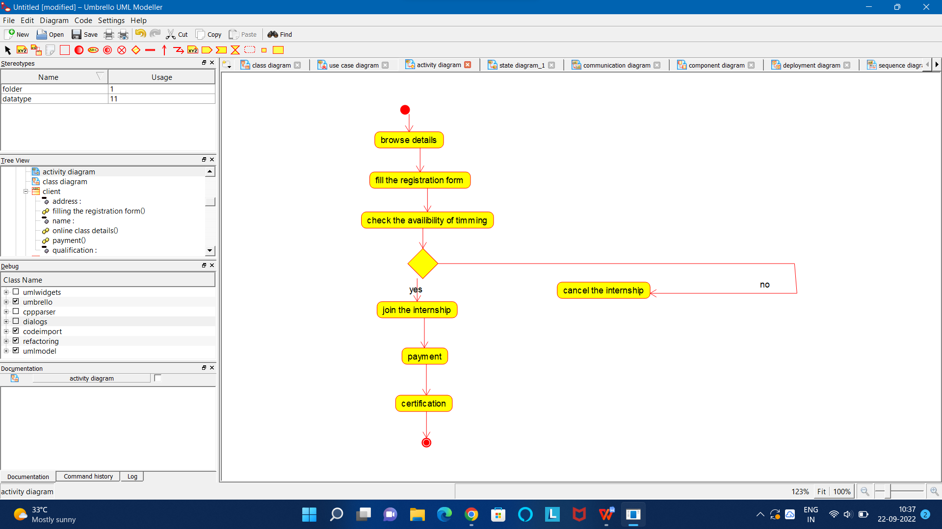

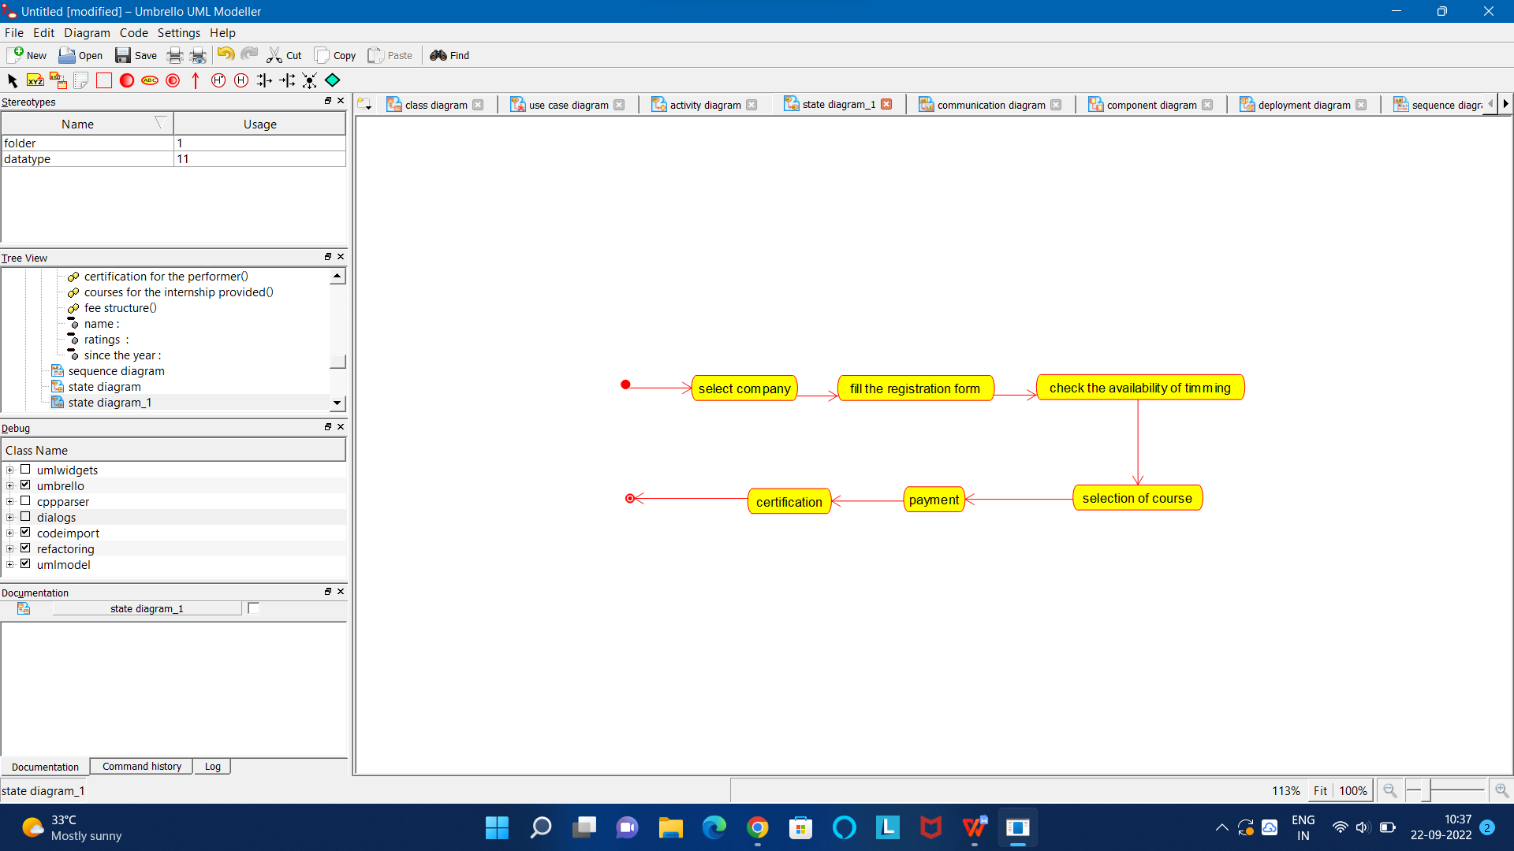

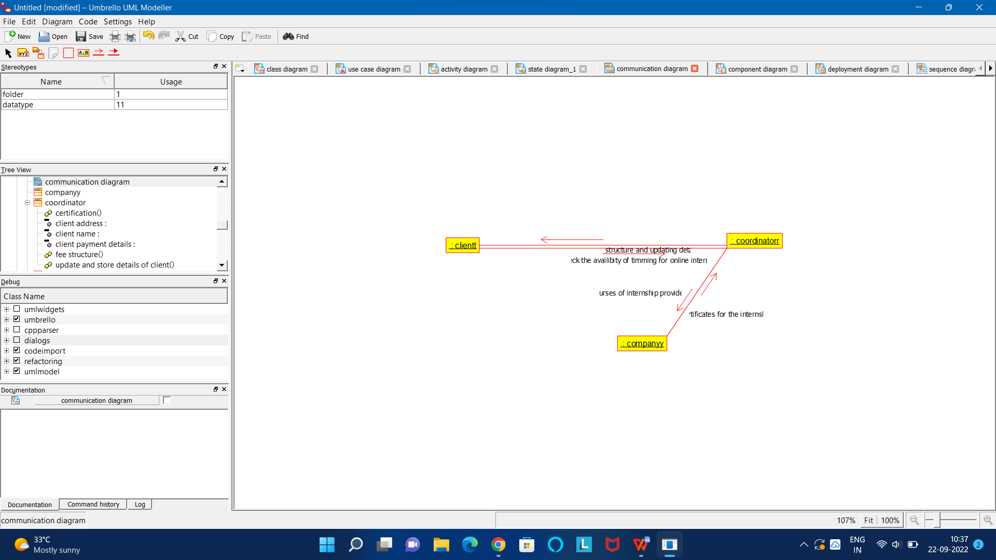

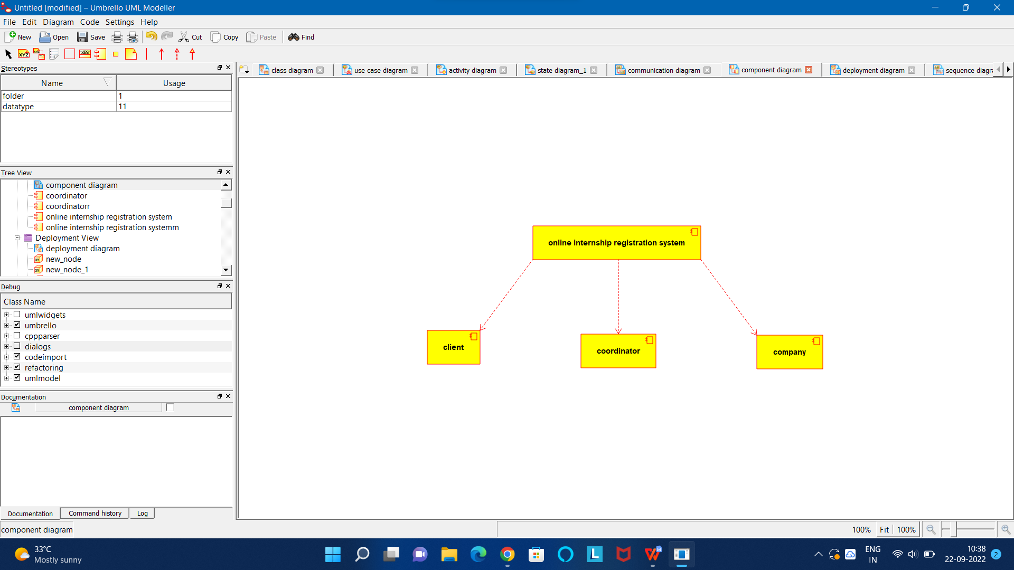

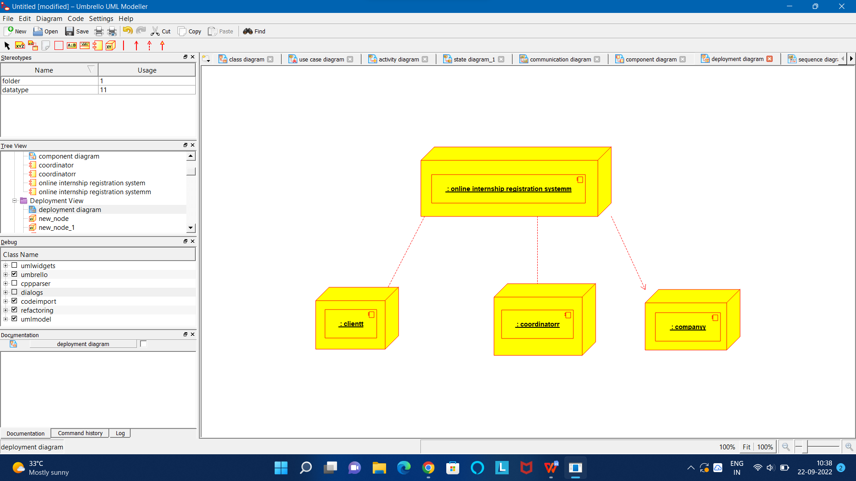

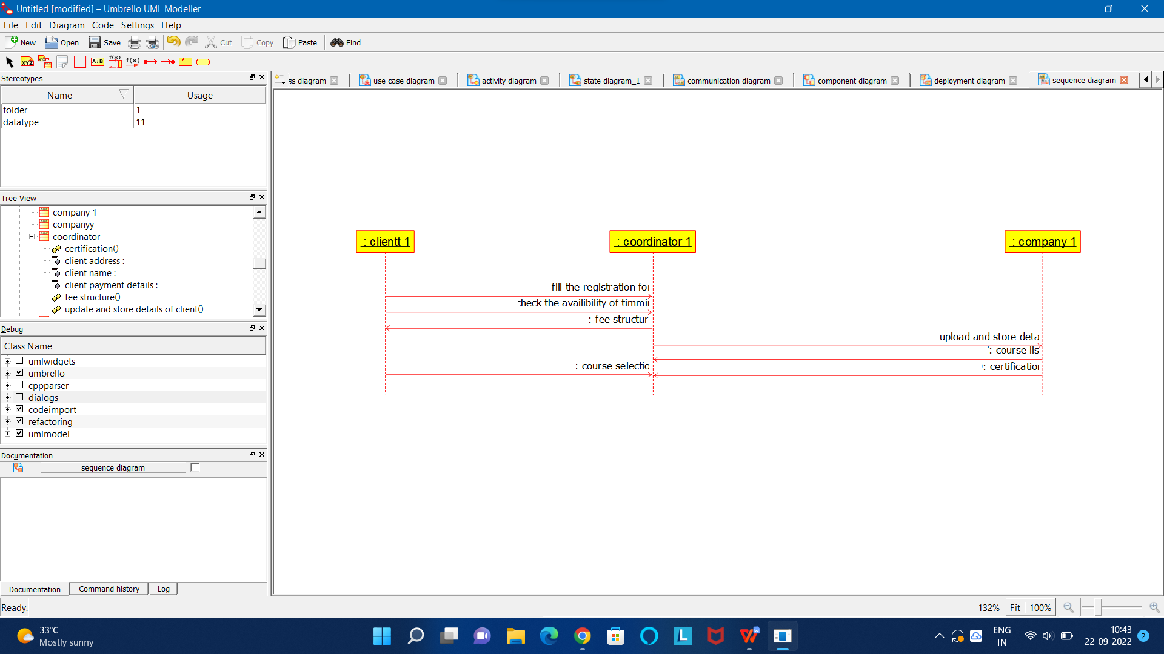

CODE FOR CLIENT:

/**

* Class client

*/

public class client {

//

// Fields

//

private void name;

private void address;

private void qualification;

//

// Constructors

//

public client () { };

//

// Methods

//

//

// Accessor methods

//

/**

* Set the value of name

* @param newVar the new value of name

*/

private void setName (void newVar) {

name = newVar;

}

/**

* Get the value of name

* @return the value of name

*/

private void getName () {

return name;

}

/**

* Set the value of address

* @param newVar the new value of address

*/

private void setAddress (void newVar) {

address = newVar;

}

/**

* Get the value of address

* @return the value of address

*/

private void getAddress () {

return address;

}

/**

* Set the value of qualification

* @param newVar the new value of qualification

*/

private void setQualification (void newVar) {

qualification = newVar;

}

/**

* Get the value of qualification

* @return the value of qualification

*/

private void getQualification () {

return qualification;

}

//

// Other methods

//

/**

*/

public void filling_the_registration_form()

{

}

/**

*/

public void payment()

{

}

/**

*/

public void online_class_details()

{

}

}

CODE FOR COMPANY:

/**

* Class companyy

*/

public class companyy {

//

// Fields

//

//

// Constructors

//

public companyy () { };

//

// Methods

//

//

// Accessor methods

//

//

// Other methods

//

}

CODE FOR CLIENTT:

/**

* Class clientt

*/

public class clientt {

//

// Fields

//

//

// Constructors

//

public clientt () { };

//

// Methods

//

//

// Accessor methods

//

//

// Other methods

//

}

CODE FOR COMPANY1:

/**

* Class company_1

*/

public class company_1 {

//

// Fields

//

//

// Constructors

//

public company_1 () { };

//

// Methods

//

//

// Accessor methods

//

//

// Other methods

//

}

CODE FOR CLIENT1:

/**

* Class clientt_1

*/

public class clientt_1 {

//

// Fields

//

//

// Constructors

//

public clientt_1 () { };

//

// Methods

//

//

// Accessor methods

//

//

// Other methods

//

}

CODE FOR ONLINE INTERNSHIP:

/**

* Class online_company_interndhip

*/

public class online_company_interndhip {

//

// Fields

//

private void name;

private void since_the_year;

private void ratings_;

//

// Constructors

//

public online_company_interndhip () { };

//

// Methods

//

//

// Accessor methods

//

/**

* Set the value of name

* @param newVar the new value of name

*/

private void setName (void newVar) {

name = newVar;

}

/**

* Get the value of name

* @return the value of name

*/

private void getName () {

return name;

}

/**

* Set the value of since_the_year

* @param newVar the new value of since_the_year

*/

private void setSince_the_year (void newVar) {

since_the_year = newVar;

}

/**

* Get the value of since_the_year

* @return the value of since_the_year

*/

private void getSince_the_year () {

return since_the_year;

}

/**

* Set the value of ratings_

* @param newVar the new value of ratings_

*/

private void setRatings_ (void newVar) {

ratings_ = newVar;

}

/**

* Get the value of ratings_

* @return the value of ratings_

*/

private void getRatings_ () {

return ratings_;

}

//

// Other methods

//

/**

*/

public void fee_structure()

{

}

/**

*/

public void courses_for_the_internship_provided()

{

}

/**

*/

public void certification_for_the_performer()

{

}

}